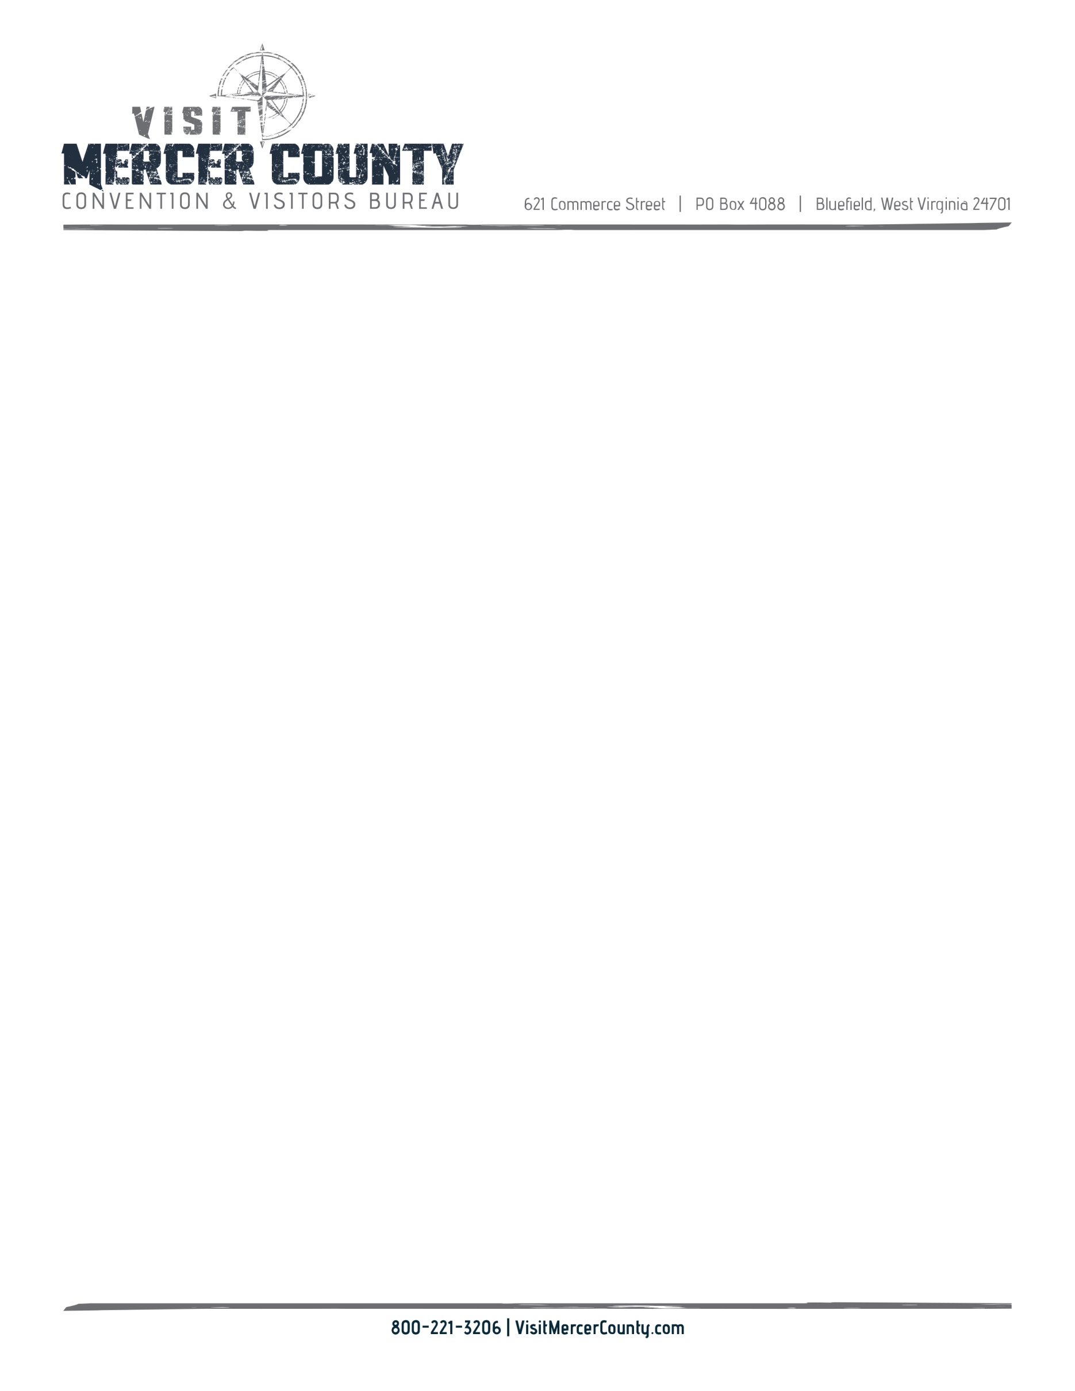

**Mercer County CVB Board Meeting**

**June 14, 2022**

1. Welcome, and call to Order & Pledge Cindy Kraft
2. Approval of September minutes Valerie Hendricks, Cindy Kraft
3. Financial Report Tammie Lucas, Henry Jones
4. New Business
5. Digital Relativity update Pat Shrader, Alexa Nagy
6. Mobile Visitor Center Karen Morris
7. Strategic Plan Cindy Kraft, Jamie Null
8. Office Update Jeff Disibbio
9. Proposal to held brand Exit 9 project Jamie Null
10. Audit Henry Jones
11. Next Meeting Jamie Null
12. Roundtable