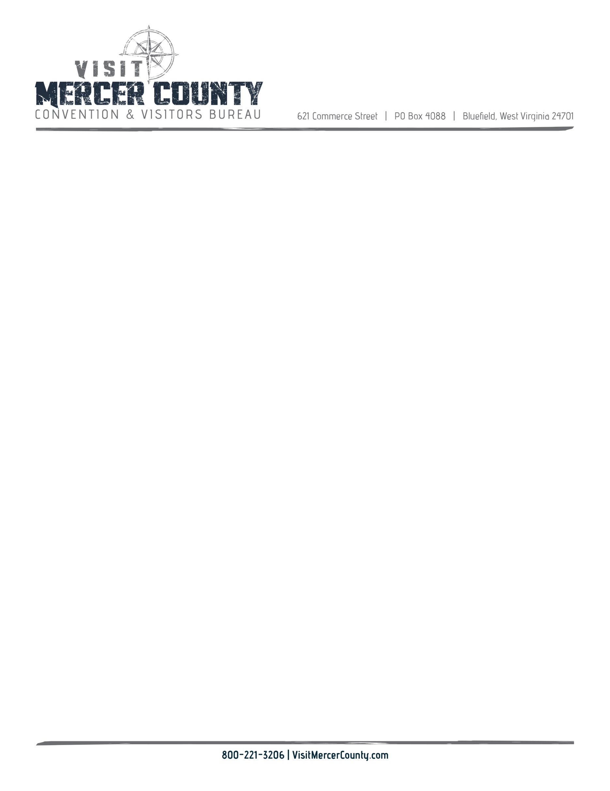

**2022**

**CVB Meeting**

**Dates and Locations**

March 8, 2022 2 PM BEDA Bluefield Area Arts Building 3rd Floor

June 14, 2022 2 PM Princeton City Offices, Council Chambers

September 13, 2022 2 PM BEDA Bluefield Area Arts Building 3rd Floor

December 6, 2022 2 PM Princeton City Offices, Council Chambers

*Meetings are subject to change based on board member availability

*In the event the meeting will be held by ZOOM, email invites will be sent out