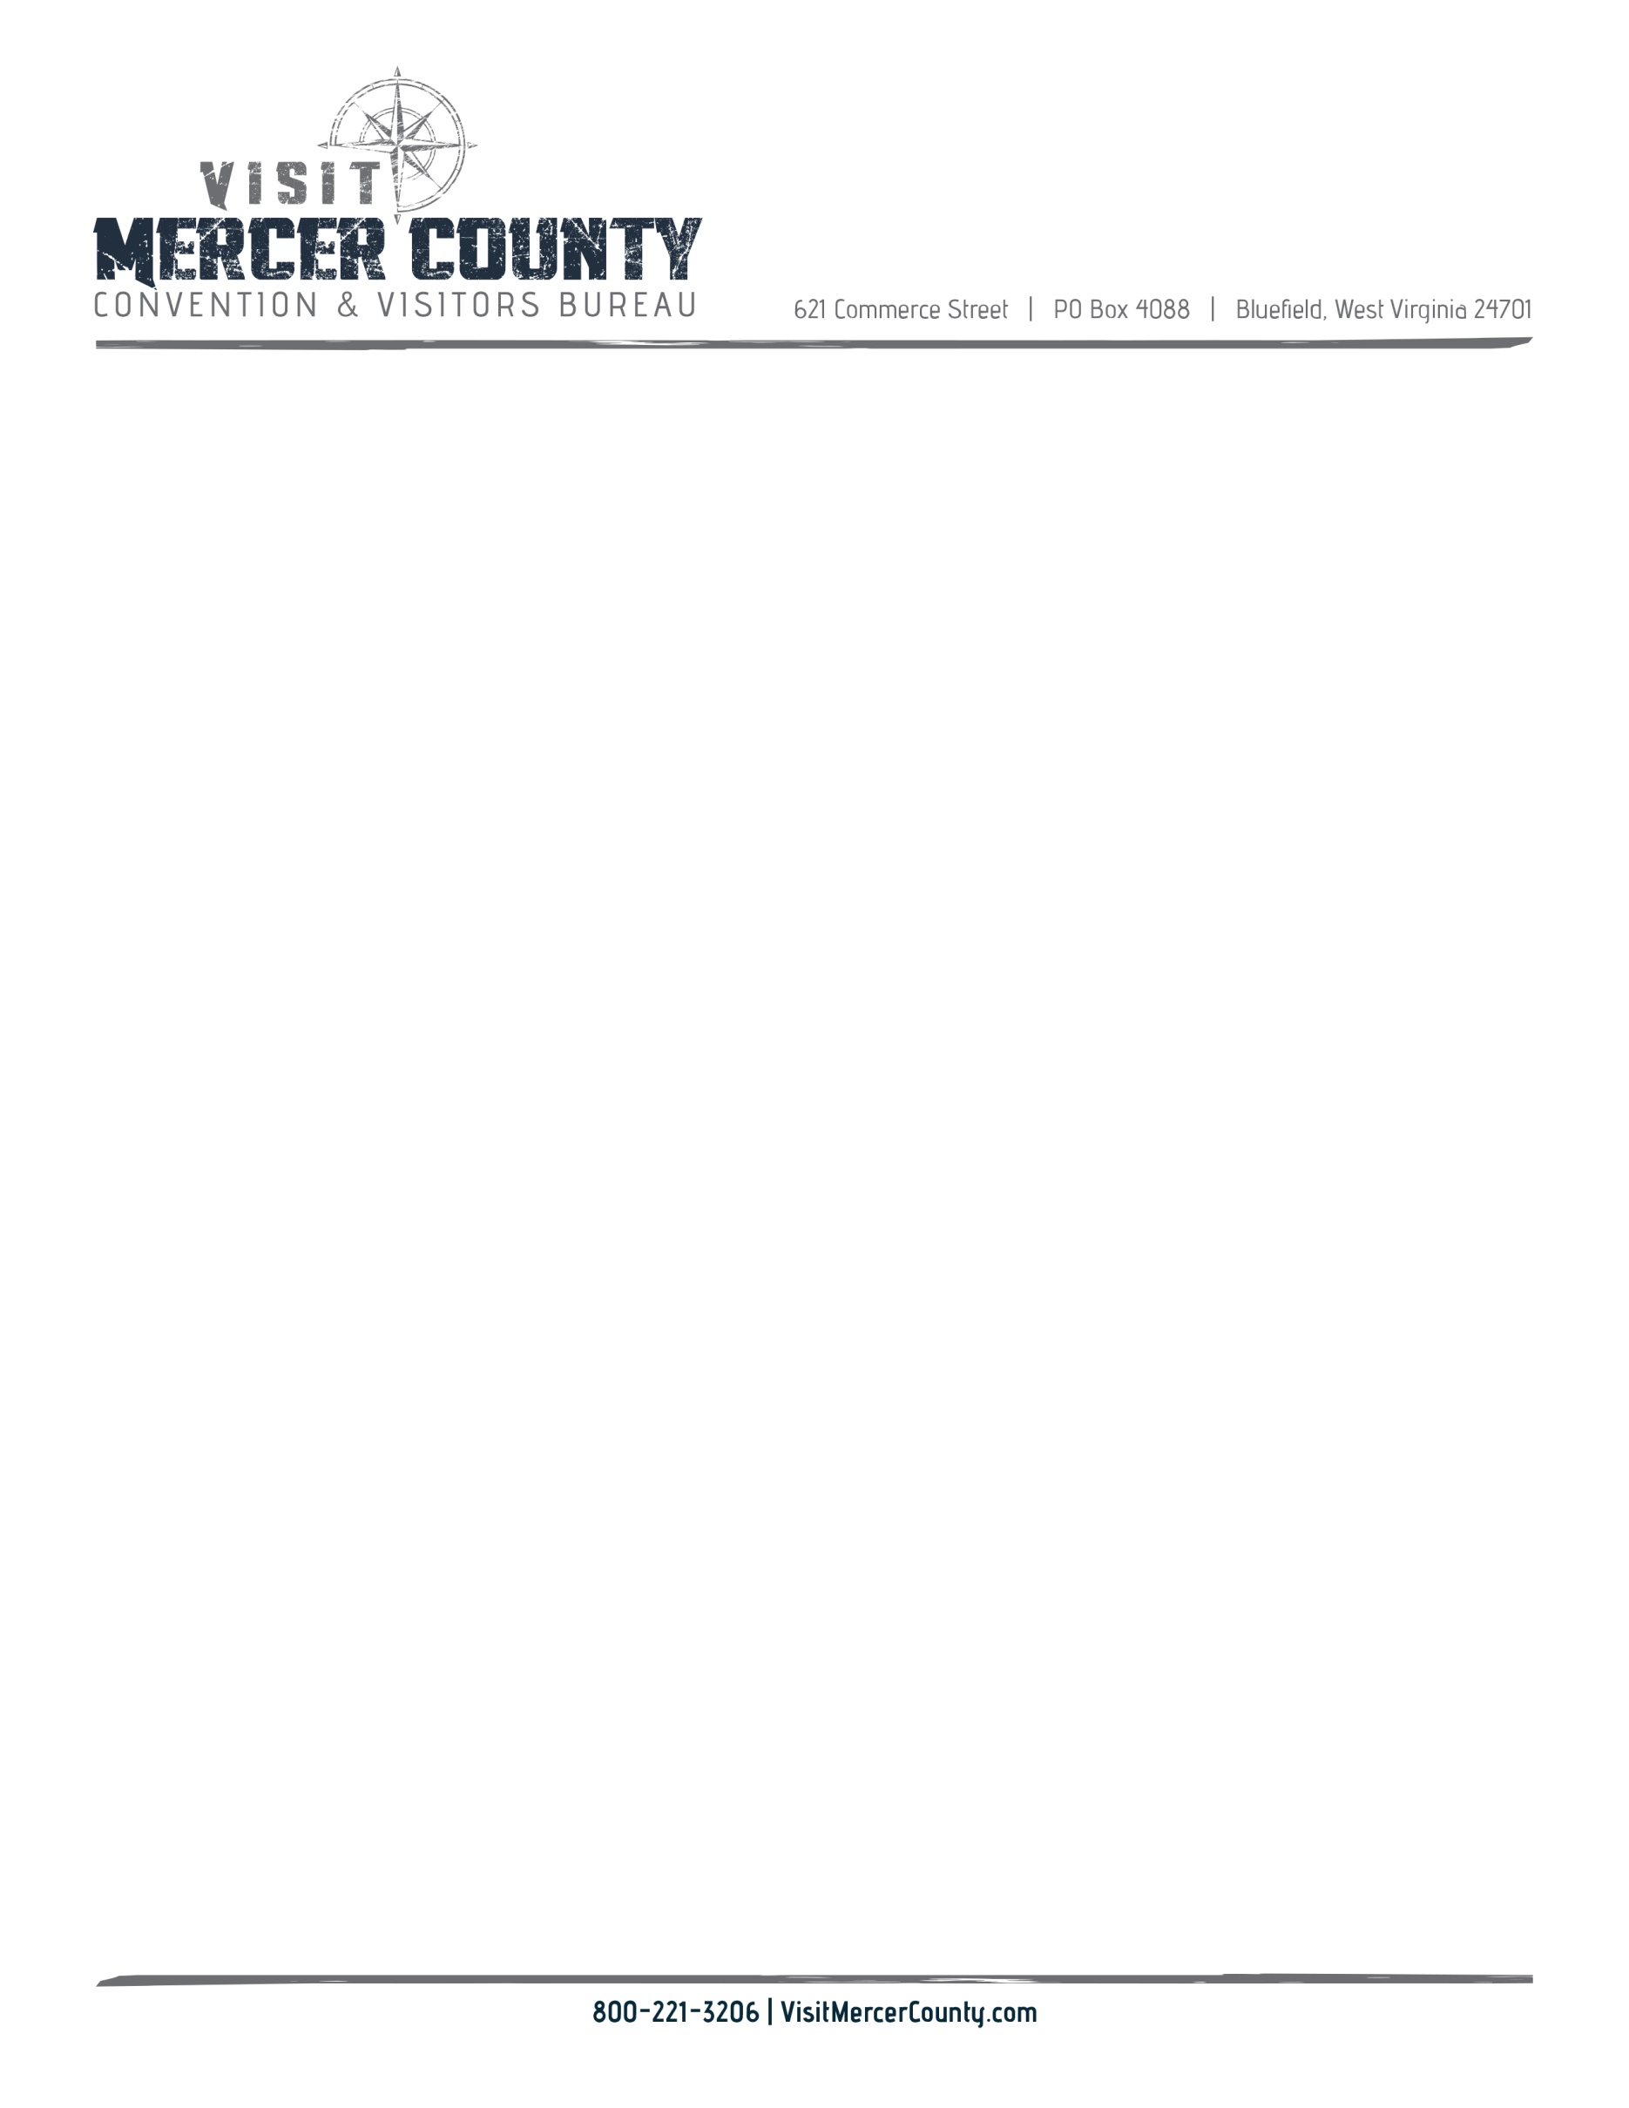

**Mercer County CVB Board Meeting**

**March 8, 2022**

1. Welcome, and call to Order & Pledge Cindy Kraft
2. Approval of September minutes Valerie Hendricks
3. Financial Report Tammie Lucas
4. New Business
5. Digital Relativity update Pat Shrader and Alexa Nagy
6. Visitor Guide 2022, annual report, marketing report Jamie Null
7. Office update Jeff Disibbio
8. Reschedule June Meeting